Vector-Adaptive Vector Quantization with Application to Speech Coding
- Weidong Kou and Jon W. Mark
IEEE Transactions on Communications, Vol. 39, No. 6, pp. 958-962, June 1991
Abstract
A vector-adaptive vector quantization (VAVQ) scheme can cope with large input dynamic ranges, can be used in either the time domain or the transform domain.
- Introduction
Vector quantization (VQ) can potentially offer high compression. In this paper, we describe a VQ approach in which the components of an adaptive adjustment vector are used to individually scale each component of the VQ codevectors.
- System Description
The proposed VAVQ is comprised of a VQ encoder with a constrained codebook, and an adjustment vector predictor. A forward or backward adaptive predictor, as shown in Fig. 1, may be used.
- Codebook Design
- Codebook Design Algorithm in Time Domain
- Codebook Design Algorithm in Transform Domain
- Simulation Results
See Table 1, 2, 3.

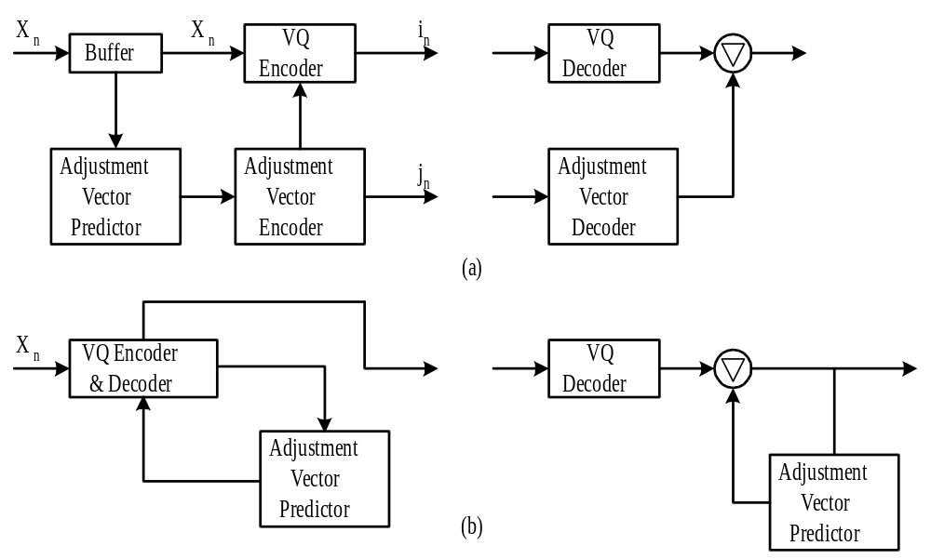
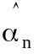
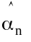
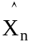
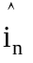
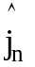
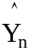
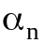
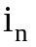
Fig.1 Block diagram of vector-adaptive vector quantization. (a) Forward VAVQ. (b) Backward VAVQ.

Table 1
Segmental SNR Versus Encoding Rate (b/sample)
Encoding Rate | 0.50 | 0.75 | 1.00 | 1.25 | 1.50
Fixed VQ | 1.77 | 5.01 | 6.01 | 8.35 | 10.44
VAVQ | 5.55 | 9.17 | 10.46 | 13.02 | 14.47

Table 2
SNR Versus Encoding Rate (b/sample)
Encoding Rate | 0.50 | 0.75 | 1.00 | 1.25 | 1.50
Fixed VQ | 5.16 | 6.86 | 8.88 | 11.06 | 13.15
VAVQ | 8.95 | 12.08 | 14.07 | 15.75 | 16.77

Table 3
Bit Allocation Schemes (b/sample)
Encoding Rate | 0.50 | 0.75 | 1.00 | 1.25 | 1.50
Bit Allocation | (5,2,1) | (8,2,2) | (8,4,4) | (8,8,4) | (8,8,8)
Created by : Chia-Hao Yang
Date : Dec 10, 1997

